Bil. Math(G8) worksheet 1: parallelogram Name: Score:
- As in the graph, in□ABCD, E is the middle point of BC, the extension of DE intersects with AB at F. Prove AB=BF.
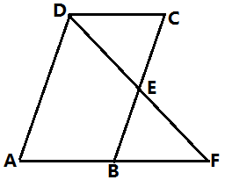

- As in the graph, in□ABCD, O is the middle point of diagonal BD, EF is a line passing through O and meets with BC, AD at F,E. Prove that AE=CF.
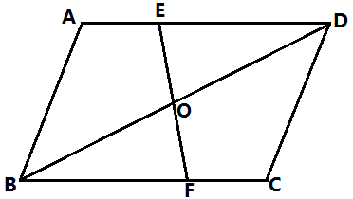

- As in the graph, in□ABCD, E is a point on BC, AB=AE. Prove that $∆ABC≅∆EAD$.
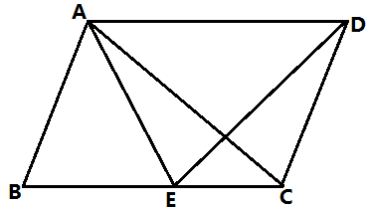

- As in the graph, in□ABCD, the angular bisector of $∠ABC$ BG intersects with AD at G, the angular bisector $∠BCD$ CE intersects with AD at E. BG and CE are intersecting at F. Prove that AE=DG.
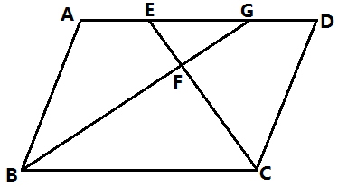

- As in the graph, ABCD is a parallelogram, $AE∥BD$, prove that BE=BC.
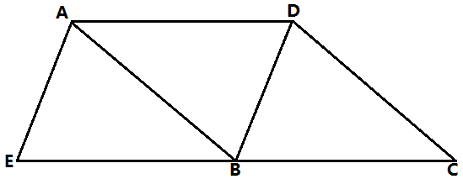

- As in the graph, points B,E,C,F are on the same line, AB=DE, $∠B=∠DEF$, BE=CF. Prove:
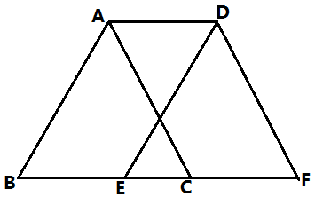
- ABED is a parallelogram
- ACFD is a parallelogram

- As in the graph, extend the median line CD to E such that CD=DE. Join AE,BE. Prove that AEBC is a parallelogram.
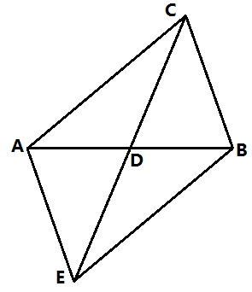

- As in the graph, in □ABCD, the diagonals AC, BD are intersecting at O, E,F are two points on BD and DE=BF. Prove that AFCE is a parallelogram.
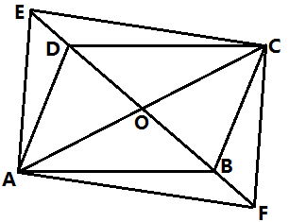

- As in the graph, D is the middle point of BC, $BE⊥AD, CF⊥AD$. Is BECF a parallelogram? Prove your statement.
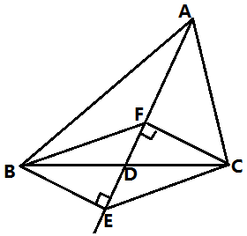

- As in the graph, in □ABCD, E,F are two points on diagonal BD, BE=DF, G,H are on the extensions of BA and DC, AG=CH, join GE,EH,HF,FG. Prove that GEHF is a parallelogram.
