Bil. Math(G8) worksheet 2: rectangle and rhombus Name: Score:
- As in the graph, ABCD is a rectangle, E,F are two points on AB and AE=BE. Prove DE=CF.
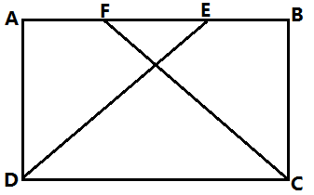

- In rectangle ABCD, the diagonals AC, BD are intersecting at O, $BE⊥AC, CF⊥BD$. Prove that BE=CF.
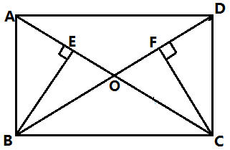

- ABCD is a rectangle(AD>AB), E is a point on BC, AE=AD, $DF⊥AE$ with foot of perpendicular F. Find the relationship between DF and AB.
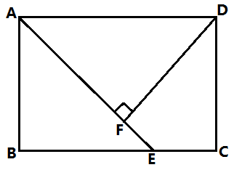

- As in the graph, in □ABCD, E,F are two points on BC, BE=CF, AF=DE. Prove that ABCD is a rectangle.
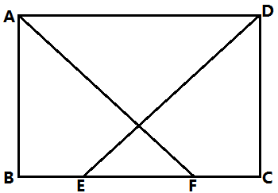

- In rectangle ABCD, the diagonals AC,BD are intersecting at O, MN is a line passing through O and meets AD at M, meets BC at N. $MN=2NC, MN⊥BD$. Prove that MN=BN.
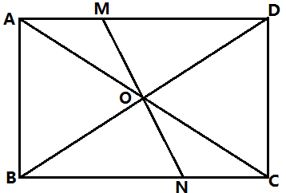

- ABCD is a rhombus, E,F are middle points of CD, AD. Prove that AE=CF.
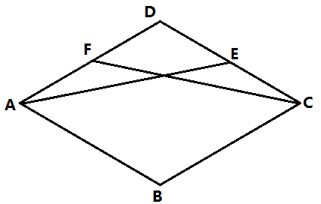

- ABCD is a rhombus, the length of the two diagonals AC,BD are 8 and 6. Move segment BD horizontally such that points C and D coincide, point B goes to E. Find the area of $∆BEC$.
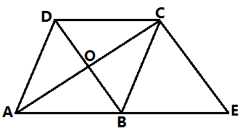

- ABCD is a square, P is a point on the diagonal AC, $PE⊥BC, PF⊥CD$. Prove that
- BP=DP (2) BE=DF
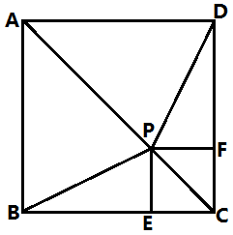

- ABCD is a square, E is a point on side BC, $DG⊥AE$, prove that BF=CE.
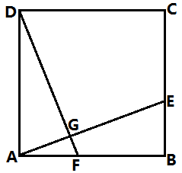

- ABCD is a square, E is a point on AB, $DF⊥DE$ where F is a point on the extension of BC. Prove that DE=DF.
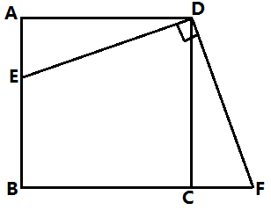

- ABCD is a square, AC and BD are intersecting at E, AF bisects $∠BAC$ and intersects with BD at F. Prove that EF+AE=AB.
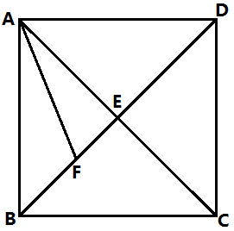

- As in the graph, in □ABCD, the diagonals AC,BD are intersecting at O, E is a point on the extension of BD such that $∆ACE$ is an equilateral triangle.
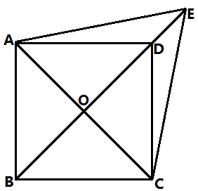
- prove that ABCD is a rhombus
- If $∠AED=2∠EAD$, prove that ABCD is a square.

