Bil. Math(G8) worksheet 2: middle line theorem Name: Score:
- As in the quadrilateral ABCD, P is the middle point of the diagonal BD, E,F are middle points of AB and CD. If $AD=BC, ∠PEF=18 °$, find the size of $∠EPF$.
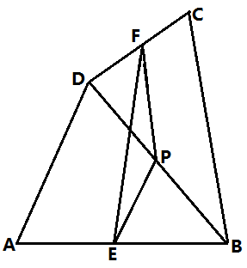

- In quadrilateral ABCD, AC=4cm, BD=5cm. E,F,G,H are middle points of AB, BC, CD, DA. Find the perimeter of quadrilateral EFGH.
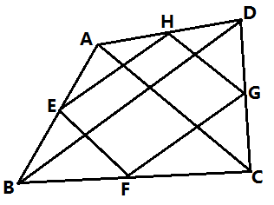

- As in trapezium ABCD, $AB∥CD, AD=CD, E,F$ are middle points of AB,BC, $∠1=35°$, find the size of $∠D$.
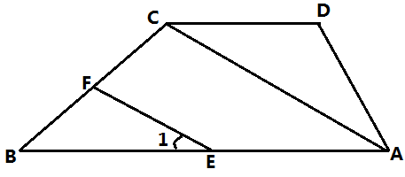

- In $∆ABC, AB=BC, BD$ is the angular bisector of $∠ABC$, E is the middle point of AB, join DE. Prove that BE=DE.
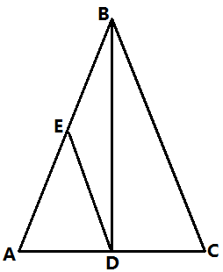

- As in the graph, ABCD is an isosceles trapezium, the length of middle line EF is 5cm, the waist AD is 4cm. Find the perimeter of the trapezium.
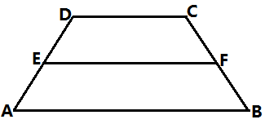

- As in the graph, ABCD is an isosceles trapezium, the perimeter is 80cm, if the middle line EF is equal to the waist AD, the height of the trapezium is 12cm. Find the area of the trapezium.

- As in trapezium ABCD, $AD∥BC, ∠B=∠ACD$.
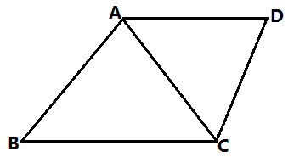
- give another pair of equal angles
- which two triangles are similar?
- if AC=6, BC=9, find the length of AD
- find the length of the middle line of the trapezium.

- In trapezium ABCD, $AB∥CD, AD=BC=4, AB=2,∠D=60°$, find the length of the middle line of trapezium ABCD.
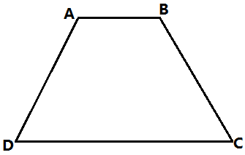

- As in rectangle ABCD, the diagonals AC,BD are intersecting at O, E,F are middle points of OA, OD. Prove that EBCF is an isosceles trapezium.
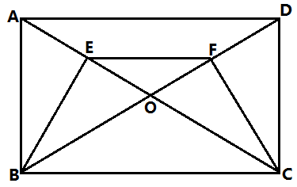

- In trapezium, $AB∥CD$, the diagonals $AC⊥BD, AC=5, BD=12$. Try to find the length of the middle line of the trapezium.
