Grade 8 Bil. Math worksheet 6:proof Name: Score:
- Fill in blanks.
- P is a point on the bisector line AD of $∠BAC, PE⊥AC$. If PE=3, then the distance from P to AB is
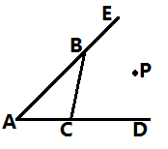
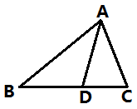
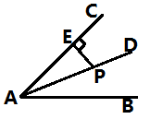

- In $∆ABC$, AD is the angular bisector, if $AB:AC=\sqrt{3}:\sqrt{2}$, then the ratio between the area $S_{∆ABD}:S_{∆ACD}$=
- Point P has equal distance to AE, BC, AC, tell True or False for each of the following statement:
① P is on the bisector of $∠BAC$
② P is on the bisector of $∠CBE$
③ P is on the bisector of $∠BCD$.
- As in the graph, AC=DB, $DC⊥OA, AB⊥OD$ with foots of perpendicular C,B. Prove
- PA=PD
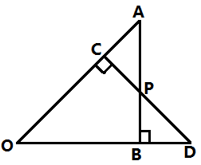
- $∠POC=∠POB$

- $∆ABC$ is an equilateral triangle, AD is the median line , $∆ADE$ is also an equilateral triangle. Prove BD=BE.
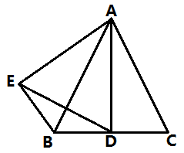

- In $∆ABC$, the bisector of $∠ABC$ intersects with the bisector of exterior angle of $∠ACB$ at P. Prove: point P has equal distance to AB, BC, CA.
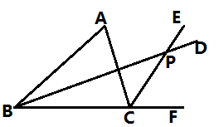

- In $∆ABC$, AB=AC, the perpendicular bisectors of AB, AB meets at O. Prove that O is on the bisector line of $∠A$
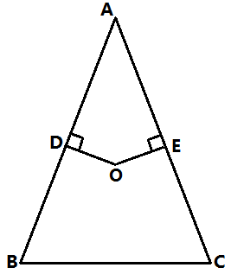

- $∆ABC$ is an isosceles triangle, AB=AC, AD is the median line of BC, the angular bisector of $∠ABC$ intersects with AD at E, $EF⊥AB$. Prove that EF=ED.
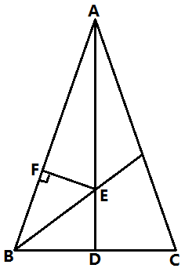

- As in the graph, $BE⊥AC, CF⊥AB$, BD=CD. Prove that AD bisects $∠BAC.$
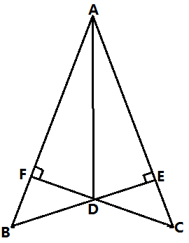

- ABCD is a quadrilateral, $∠A=60°,∠B=∠D=90°$, AB=4, CD=2. Can you find the length of AD, BC?
