Grade 8 Bil. Math worksheet 5:proof Name: Score:
- As in the graph, A,B are two point and l is a line. Find a point P on l such that PA=PB. Keep your drawing trace.
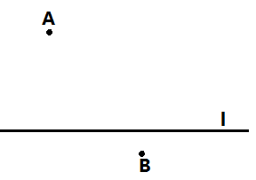

- In $∆ABC, ∠C=90°, ∠A=36°$, the perpendicular bisector of AB intersects with AB at D, with AC at E. Find the size of $∠EBC$
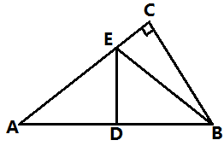

- In $Rt∆ABC, ∠C=90°, ∠A=30°$, BD bisects $∠ABC$. Prove that D is on the perpendicular bisector line of AB.
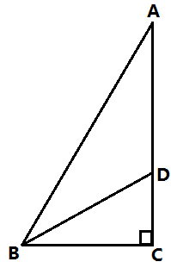

- In $∆ABC$, the perpendicular bisector of BC intersects with AC at D, with BC at E. Prove that AB<AC.
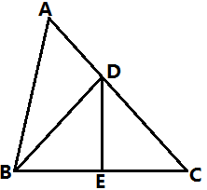

- In $∆ABC$, $AD⊥BC, ∠B=2∠C$. Prove that AB+BD=DC
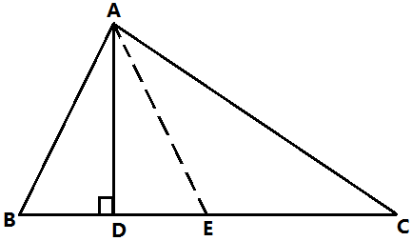

- In $∆ABC$, AB=AC, P, Q, R are points on AB, BC, CA. PB=QC, QB=RC, prove that Q is on the perpendicular bisector line of PR.
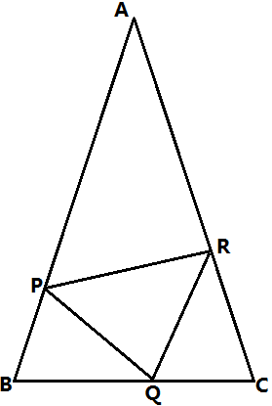

- In $∆ABC$, AD bisects $∠BAC$ , EF is the perpendicular bisector of AD. Prove that $∠B=∠CAF.$
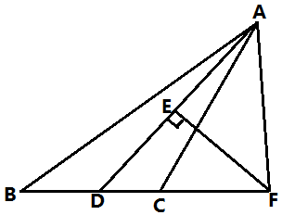

- In $∆ABC$, $∠C=90°$, $∠B=30°$, the perpendicular bisector of AB intersects with AB at D, with BC at E. Prove that CE=DE.
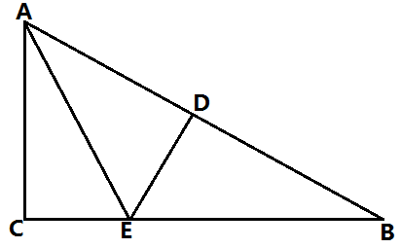

- In $∆ABC$, the perpendicular bisector of AB intersects with AC at E. The perimeter of $∆BCE$ is 8, AC-BC=2. Find the length of AC, BC.
