Worksheet: Definitions in Function
- Which of the following is a function? State your reason.

- (b)
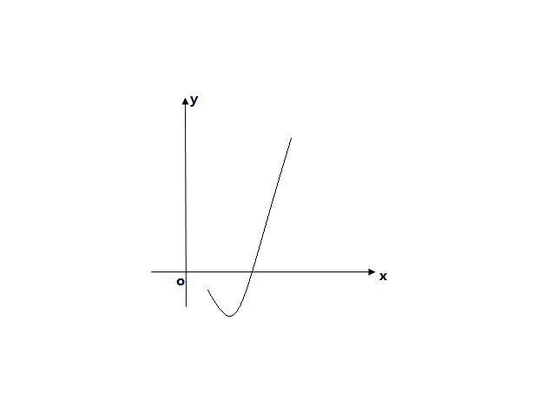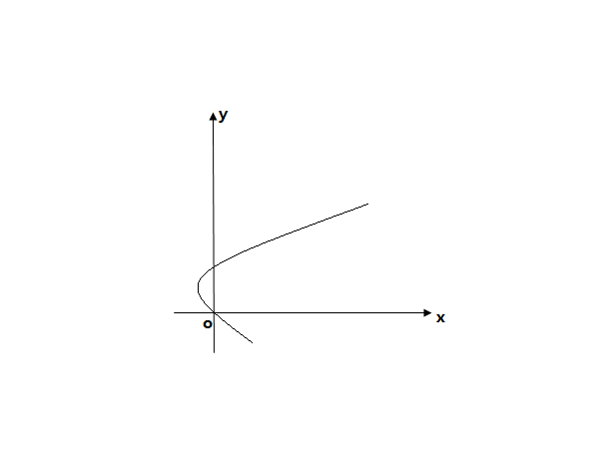

(c) (d)
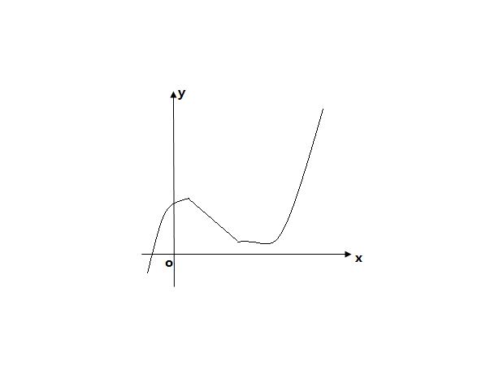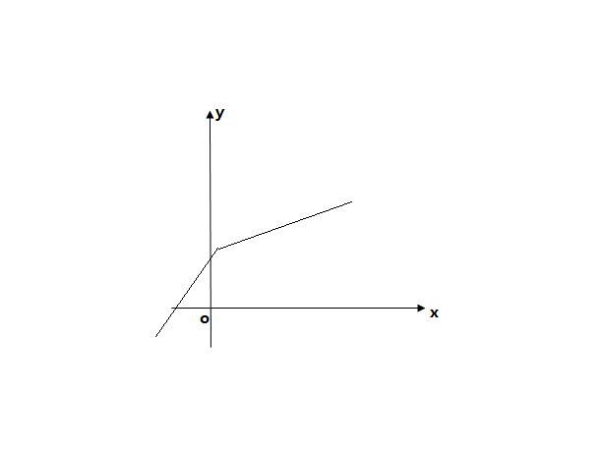
- Determine whether each of the following relations is a function or not? State your reason.

- (b)
1
2
3
1
2
9
2
5
7
3

4

(c) (d)

7
8
9
4
5
7
-1
2
6
9
3
5
8

- For the function f(x)=3x-5, evaluate
- f(2) (b) f(0)

- If f(x)=2x+1, write down the following in their simplest form
- f(x+1) (b) f(x)-x

- A function is defined by f:x$→{2x}^{2}+1$ with domain X={-1,2,3}. Find the image set of f.

- A function g is defined by g:x$→3+\frac{6}{x-1},x≠1$
- Find the images of -1,1/2 and 5/4
- Given that the image of a is 2a, find the possible values of a.

- A function f is defined by f:$→ax+b$. The images of 1 and 5 are -2 and 10 respectively.
- Calculate the value of a and b
- If the domain of f is X={1,3,5}, find the range of f.

- A function is defined by $f→{ax}^{2}+bx+c$. Given that f(1)=6, f(3)=32, f(-2)=-3. Find
- The values of a, b and c
- The positive number x whose image is 2
- The set of numbers whose image under f is 2.

