IGCSE1 math worksheet: graph in practical situation Name: Score:
- Question 2 from exercise 17.1

- Question 5 from exercise 17.1

- Question 3 from exercise 17.3

- Question 1, 2 and 5 from exercise 17.5(no need to draw the graph)

- Question 3 from exercise 17.6.

- Question 3 from exercise 17.7

- Question 7 from exercise 17.7

- The right hand side is an velocity-time diagram of a
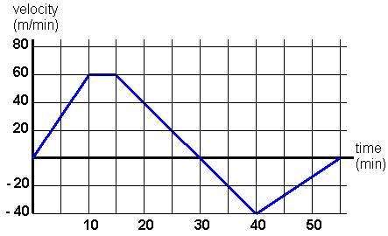
car.
- Describe the movement of the car
- Find the total distance in 55 minutes.(位移)

