IGCSE1 math worksheet1: Linear programming Name:
- Draw the graphs for each of the following in the coordinate system
- y=x (2) y=2x-1 (3) y=-x-1 (4) 2x+y=3
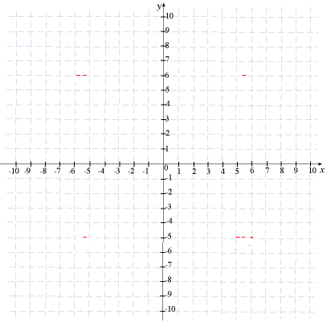

- Graphing the inequality for each one, shade the part satisfies the inequality.
- $y>x$ (2) $y<x+1$ (3) $2x+y<4$
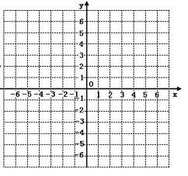

(4) $x≤y+1$ (5) $y≤-2x-2$ (6) $2y-x<4$

- Graphing the simultaneous inequalities in a coordinate systems, shade the required part.
- $\left\{\begin{aligned}x≤2 \\ y>-1 \\ y≤3\end{aligned}\right.$

- $\left\{\begin{aligned}y≤x \\ y>1 \\ x≤5\end{aligned}\right.$ (3) $\left\{\begin{aligned}x+y≤6 \\ y<x \\ y≥1\end{aligned}\right.$ (4) $\left\{\begin{aligned}2y≥x+4 \\ y≤2x+2 \\ y<4 \\ x≤3\end{aligned}\right.$

- Find the inequalities represented by the shaded part.
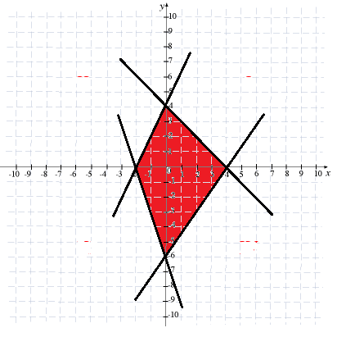

- Linear programming.
- Max $x+2y$ (2) Min y-2x (3) Max x+y
s.t. $\left\{\begin{aligned}2x+6y≤9 \\ x≥0 \\ y≥0\end{aligned}\right.$ s.t. $\left\{\begin{aligned}x+y≤10 \\ x≥2 \\ y≥2\end{aligned}\right.$ s.t. $\left\{\begin{aligned}x+2y≤4 \\ 4x+2y≤12 \\ -x+y≤1 \\ x≥0 \\ y≥0\end{aligned}\right.$

