Bil. Math(G8) worksheet 2: trapezium Name: Score:
- As in the graph, in trapezium ABCD, $AD∥BC, AB=CD, DE∥AB, ∠B=60°$. Prove that $∆CDE$ is an equilateral triangle.
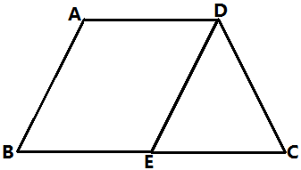

- As in trapezium ABCD, $AD∥BC, AB=DC$, E is the middle point of BC, $EM⊥AB, EN⊥CD$ with foot of perpendicular M, N. Prove that EM=EN.
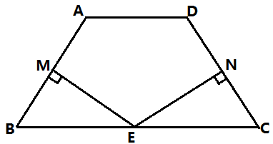

- As in trapezium ABCD, $AD∥BC$, CA bisects $∠BCD, DE∥AC$ and intersects with the extension of BC at E, $∠B=2∠E$. Prove that AB=DC.
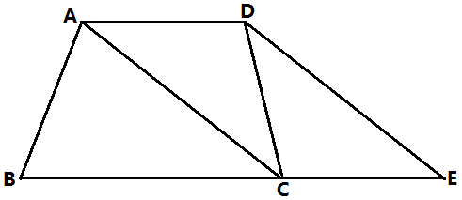

- In isosceles trapezium ABCD, $AB∥CD$, E,F are two points on AB, AE=BF, DE and CF are intersecting at O.
- Prove that OE=OF
- If EF=CD, join DF, CE, what kind of special quadrilateral
DCEF is ? Prove your statement.
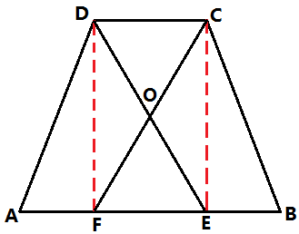

- In trapezium ABCD, $AB∥CD$, E is the middle point of DC, if AE=BE, then is ABCD an isosceles trapezium? Prove your statement.
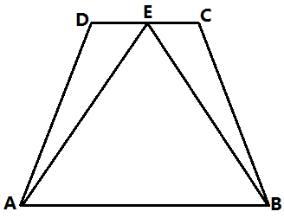

- ABCD is an isosceles trapezium, $AD∥BC, ∠B=60°, AB=AD, E$ is a point on AD, F is a point on AB, AE=BF. Compare the length of CE and DF.
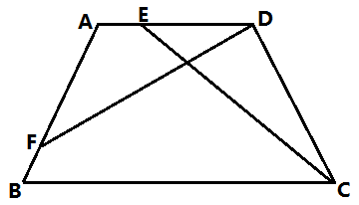

- As in the graph, in $∆ABC$, $AB=AC, BD⊥AC, CE⊥AB$ with foot of perpendicular D,E. Join DE. Prove that BCDE is an isosceles trapezium.
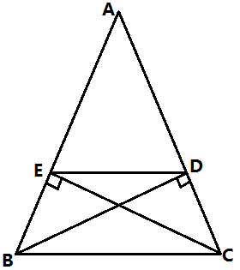

- ABCD is a rhombus, $∠DAB=60°,CE⊥AC$ and intersects with the extension of AB at E. Prove that AECD is an isosceles trapezium.
