IGCSE1 math worksheet: area of a triangle Name: Score:
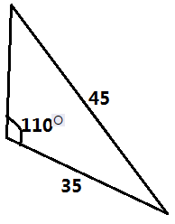
- Calculate the area of the following triangles.
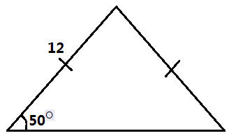
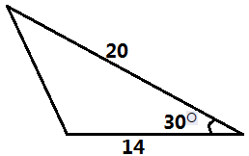

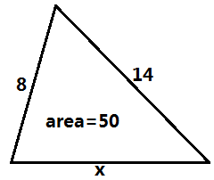
- Calculate the value of x in each of the following.
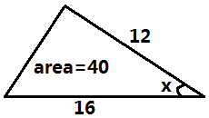
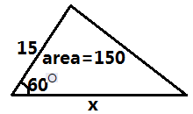

- The roof of a garage has a slanting length of 3m and makes an angle of $120°$ at its vertex. The height of the walls of the garage is 4m and its depth is 9m. Calculate:
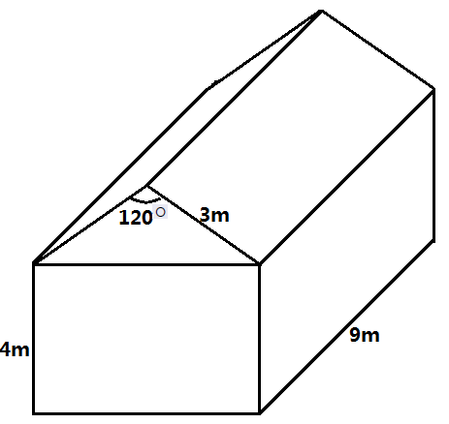
- the cross-sectional area of the roof
- the volume occupied by the whole garage.

