**IGCSE1 math worksheet: trigonometry in 3D Name: Score:**

1. (1) Calculate the length HF



(2) Calculate the length HB

(3) Calculate the angle BHG.



1. (1) Calculate the length CA

(2) Calculate the length CE

(3) Calculate the angle ACE



1. (1) Calculate the length EG

(2) Calculate the length AG

(3) Calculate the angle AGE

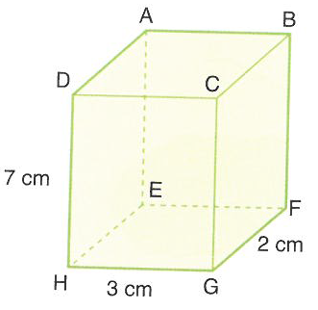

1. (1) Calculate the angle BCE

(2) Calculate the angle GFH

1. The diagram shows a right pyramid where A is vertically above X

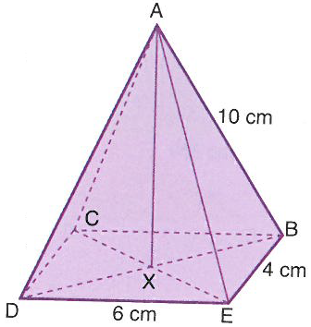

1. Calculate the length DB
2. Calculate the angle DAX
3. Calculate the angle CED
4. Calculate the angle DBA
5. Calculate the height AX
6. Calculate the volume of the pyramid
7. The diagram shows a right pyramid where A is vertically above X. Calculate



1. the length CE
2. the angle CAX
3. the angle BDE
4. the angle ADB
5. the length AX
6. the volume of the pyramid



1. In the cone, the angle $∠YXZ=60°$. Calculate
2. the length XY
3. the length YZ
4. the circumference of the base
5. the surface area of the cone
6. One corner of this cuboid has been sliced off along the plane QTU. WU=4cm. Calculate
7. the length of the three sides of the triangle QTU



1. the three angles P,Q and T in triangle PQT
2. the area of triangle PQT
3. the volume of the left over shape