**IGCSE1 math worksheet:** the angle between a line and a plane  **Name:**

1. Name the projection of each line onto the given plane



1. TR onto RSWV
2. TR onto PQUT
3. SU onto PQRS
4. SU onto TUVW
5. PV onto QRVU
6. PV onto RSWV
7. Name the angle between the given line and plane.



1. PT and PQRS
2. PU and PQRS
3. SV and PSWT
4. RT and TUVW
5. SU and QRVU
6. PV and PSWT
7. As in the graph



1. calculate the length of BH
2. calculate the angle between line BH and plane EFGH



1. As in the graph, calculate
2. the length of AG
3. the angel between line AG and plane EFGH
4. the angle between line AG and plane ADHE
5. The diagram shows a right pyramid where A is vertically above X. Calculate
6. the length BD

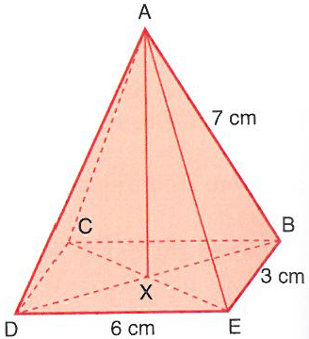

1. the angle between AB and CBED
2. the area of triangle ABD
3. the height AX
4. the volume of A-BCDE
5. The diagram shows a right pyramid where U is vertically above X. Calculate
6. the length WY



1. the length UX
2. the angle between UX and UZY
3. ABCD and EFGH are square faces lying parallel to each other. Calculate



1. the length DB
2. the length HF
3. the vertical height of the object
4. the angle between line DH and plane ABCD



1. Using the triangular prism, calculate
2. the length AD
3. the length AC
4. the angle between AC and CDEF
5. the angle between AC and ABFE
6. The cuboid has one of its corners removed to left a flat triangle BDC. Calculate



1. the length DC
2. the length BC
3. the length DB
$∠CBD$

4. the area of triangle BDC
5. the angle between AC and AEHD