Grade 7 Bil. Math worksheet1: Linear function Name: Score:
- In the following, which ones are linear functions.
- $y=2x+1$ (2) $y=-\frac{1}{2}x-3$ (3) $y=-x$

(4) $y=x^{2}$ (5) $y=\frac{1}{x}$ (6) $y=\sqrt{x+1}$

(7) $y=x^{3}$ (8) $y=0.00001x+0.000001$

- Draw the graph for each linear function.
- $y=x$ (2) $y=2x$ (3) $y=2x-1$
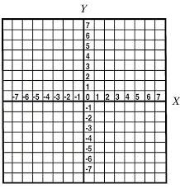

(4) $y=-x$ (5) $y=-2x$ (6) $y=-2x+2$

(7) $y=\frac{1}{2}x$ (8) $y=-\frac{1}{2}x$ (9) $y=\frac{1}{3}x+2$

- The price of rice is 2.2dollars/kg. The shop charged you y dollars for x kg rice. Is y a linear function of x? Find the expression of y in terms of x.

- A linear function is $y=2x+b$, if point (2,5) is one point lies on the line $y=2x+b$, find the value of b.

- There is a line$y=kx+b$, two point (0,4) and (1,1) lies on the line. Find the line equation.

